Game Behavior Expectation:
The game operates entirely under .NET package and Splashkit library, using C# and possibly Console App as the base. No other libraries, engines, package should be expected.
It’s expected that the final program design should obey all of SOLID and GRASP principles within its scopes. The same for design patterns (currently, there are patterns such as State Patterns, Singleton Patterns,...). Last but not least, OOP best practices.

Screens:
- Start Screen (StartScreenState):
+ New Game (button): Start a new game from the beginning of the story
+ Continue (button): Open a Save and Load Menu
+ Options (button): Open to an Option Screen, where several options to modify settings like sound. However, this is optional currently (could place a implemented later warning if needed)
+ Exit (button): Exit the Program
+ Background (Image): A possibly static or infinitely (something related to 7 could be good) vertically (preferably?) or horizontally looping image
+ No other state should be active here
Example:

- Save and Load Menu screen (SaveLoadState):
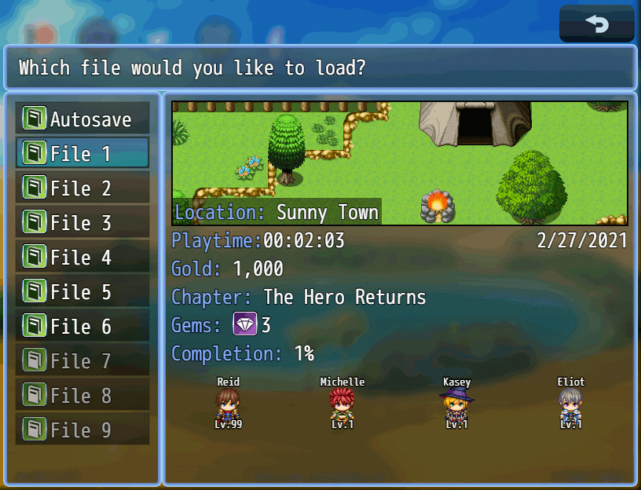

Instead of Chapter, it would be Loop. (Ex.: Loop: 4).
Playtime and date/month/year would be recorded through system, based exactly on their timezone.
No Gems, (optional) could be Corruption Meter if it’s revealed during the specific loop in-game. I should have already specified how this work before, but the details may appear below.
(Optional) There is only one character sprite and slot, with the name but no level.
Everything else is the same.
Limited to 7 save slots (that can hold 7 load files, reiterating to make sure).
You can press S to save.
- Main Gameplay Screen:
+ Exploration State:
Example:
Village:
+ You can walk in four directions
+ You can inspect things by pressing I (since map is an image, maybe a hitbox or something similar like collision will be implemented). Yes, you can inspect npc, leading to a name and a short description (a description basically, no long or short version).
+ You can start conversation with npc by coming into range of 1 block of their current position and press E, where they will play a default line.
+ It would be great if there are indicators in UI on the player’s head if it’s things like house. If it’s NPC, it will on the npc sprite’s head or somewhere easily seen.
+ You can enter locations.
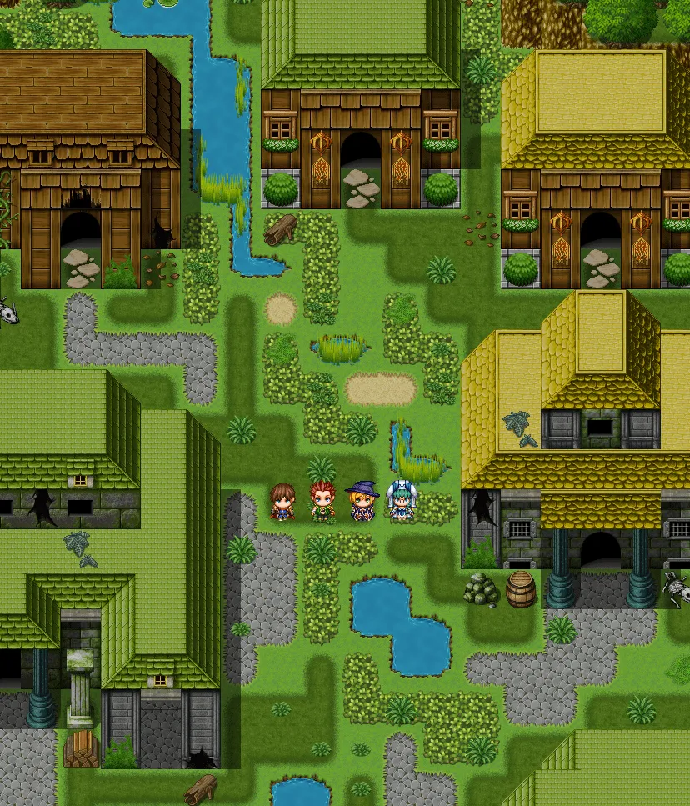

+ Battle State:
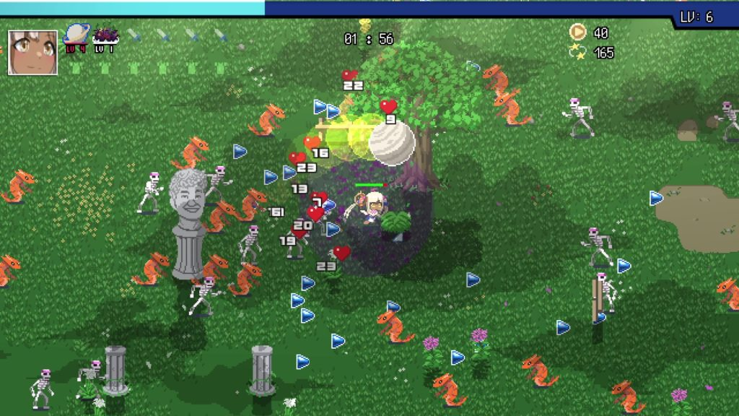

This example is from Holocure. The only difference would be that:
+ There are not this many beasts
+ Beasts have 3 states: Normal, Partial Corruption (Partial) and Corruption (Full) but they don’t have a lot of varieties in look. They also don’t drop those small stuff on death and there is no exp bar at the top.
+ There is a mandatory hp bar at the top left with numerical values
+ No lines of weapons and accessories (the ones on top left for holocure)
+ No gold coins, total kill or time recorded
+ No face avatar on top left
+ CombatState is activated by coming into aggro range of a beast, who will began to target you.
+ The map is now like a platformer map but no platform, where player can only, exclusively walk and attack in 2 directions (left and right, no up or down).
+ When all beasts within range are killed, CombatState is deactivated.
+ Dialogue State:
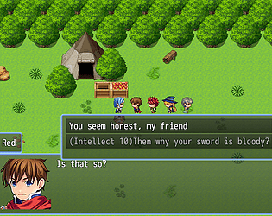
It’s simply like this. There are several options and notes:
+ The dialogue and answer should honestly not overlap any character sprite that is the player (may overlap npc sprite since their position is fixed, unless it’s the npc the player is interacting with)
+ The answer/player dialogue choice doesn’t have to be a small branch-off from the main dialogue box, it could also be presented directly within the box with yellow (flexible) box highlights.
+ There is only one main playable sprite
+ During this state, any active states like Exploration State will become inactive until dialogue is finished. Players in other states like CombatState, SaveLoadState,…can’t enter this state.

+ Loop Reset State:
It’s basically like New Game, but with some saved data. This saved data is the Favor Meter and the Knowledge Clues.
Everything else like inventory (containing items), activated questline, activated rewards (eg. access to special subareas) are wiped. This does not include the Cult altar area, as it’s activated by knowledge clue
This state may not be officially a state class, just a new game with Loopmemory active with knowledge clues.
Ending State:
A state that is the ending. All states stop after this state is achieved. This state is a black screen with a white Up? and Down? (clickable, like button but only text). Up? starts a complete new game and wiped LoopMemory and anything related to data persisting through loops. Down? makes two options disappear and a text appeared, saying “The void embraces you.” Before quitting the game after 7 seconds.
The ending “Preservation” also features a black screen after the player’s corruption didn’t decrease below 77% after 3 warnings from the daughter. As the night of the day of the 3rd warning passed, player will be instantly blackscreened with a white text “Curiosity kills the cat, Stubbornness kills mankind”

The ending “Lullaby” happens when there are not enough clues to uncover the daughter’s secret affiliation with the outer god. As the last day of loop 7 passes, no matter if the player chose to sleep or not, they will be blackscreened with the text “Sleep well, Father”.

The ending “Escape” happens when you choose the 2nd help option from the God of Give and Take within the Receive Help section.

Essential Functions:
+ Movement: Must be able to move in 4 directions in exploration state in all areas except Jungle. In Jungle, this will be 2 directions, left and right.
+ Sprites: Player, Beast, NPC, Map (png with defined block like [0,1,0…]?)
Prioritize Player (1) and beasts being able to have action animation. Beasts could be minimal, since I don’t expect complex combat strategies.
Most NPC sprites are to be static, but can change positions based on PERIOD and DAY (for example, Nanny can be at Village on Day 1 (all day) but can be at ShrineArea on Morning, Day 2.
+ Collision:
Player (sprite) and Beasts should have a hitbox.
Player can have an extension box use when attacking (left mouse) that can interact with beast's hitbox (should be the slash effect/player animation box).


Static assets, such as NPC sprites should prevent players from passing through or overlapping.
Maps (png images) should have defined blocks and body to stop player from “walking over”/overlapping.
There should be defined coordinates at the door where player can interact with and enter the insides of some things, like entering Home from Village.
Villages have 3 subareas, like VillageInner and such:
The red circling indicates the spot at which inspection can be done and where the item is
The red lines indicated the border at which the player cannot pass, or simply, define the space which they could move inside while showing which part can’t be passed into

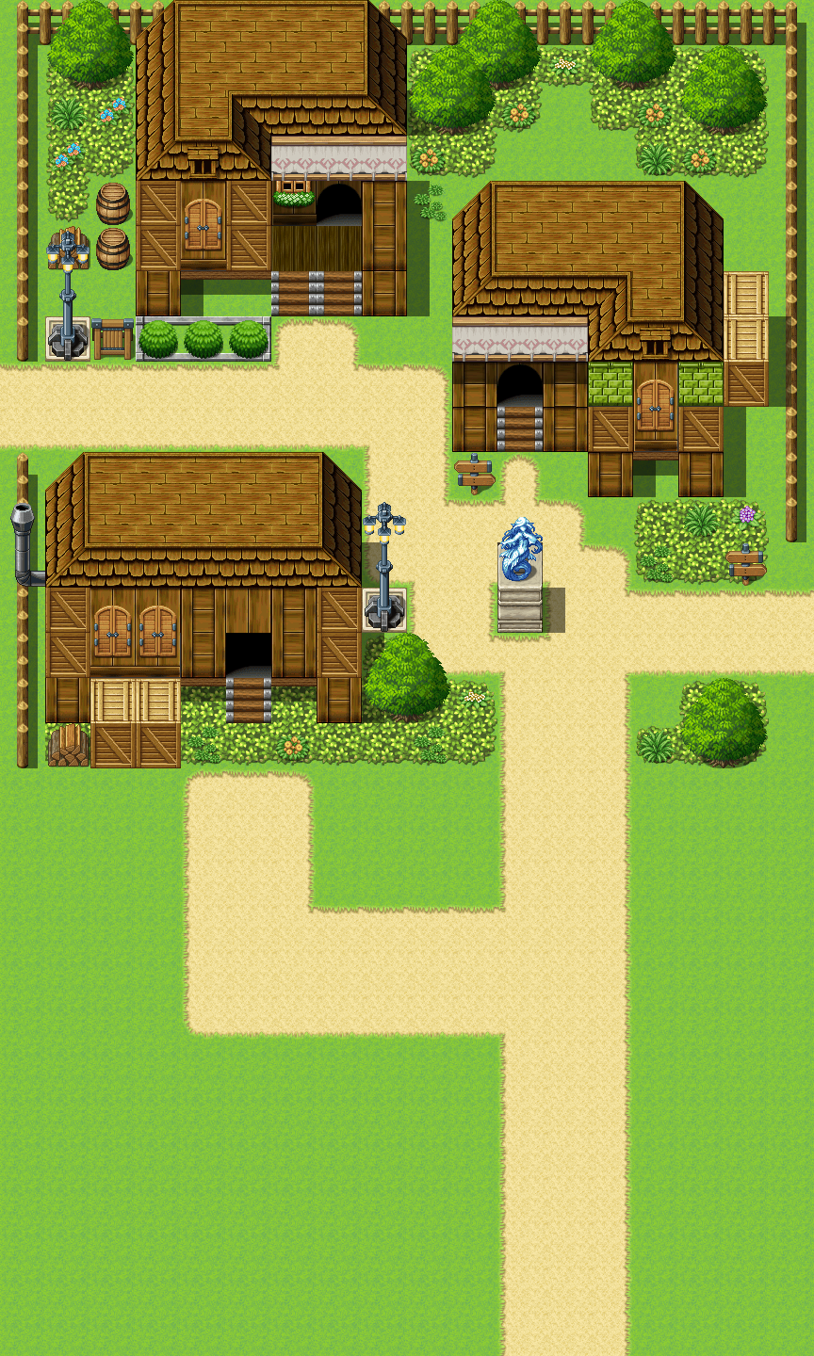
1. VillageEntrance
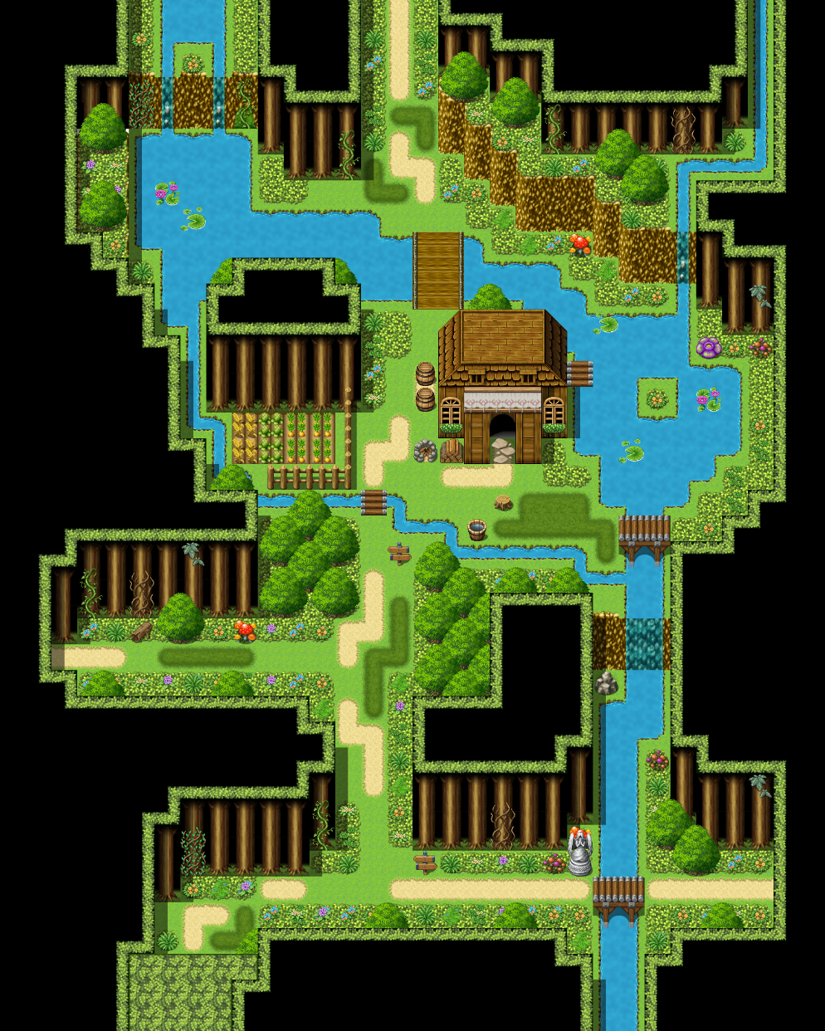
2 VillageMiddle
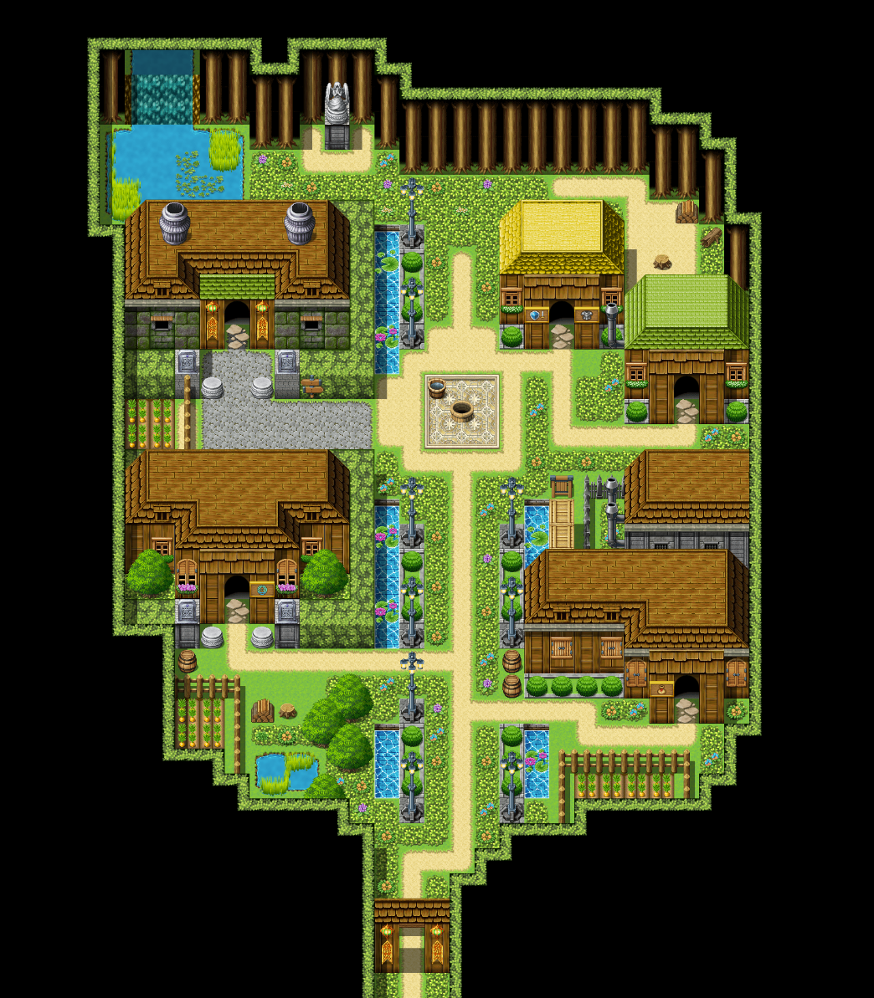
3 VillageInner

+ Interactable Objects:
Excluding certain background static assets, like trees and the ground, most objects are interactable to some degree.
Preset blocks like houses, caves, cliffs, etc can trigger an inspection effect (press a button to inspect with notifications of that and if pressed, show a dialogue line of predefined player’s thought).
Inspecting NPC can show a brief description of them, including name.
Esc can help exit this.
+ NPCs:
NPCs are special interactable objects that player can have a DIALOGUE with other than INSPECTING, with several dialogue choices.
NPCs can change location, as mentioned above.
NPCs can hold DailyRequest. Details in Request section.
Initiating a talk doesn’t cost AP.
Opening lines may differ depending on the period/day, but most dialogue choices remain the same.
During a specific period in time (for example 3rd day, 1st loop, evening), an unique option may appear if you decided to talk to them after finding them.
This will be elaborated on more in dialogue.
There are 8 interactable NPCs:
- Nanny
- Ignorant Witch Melia
- Retired Priest Koban
- Boasting Knight Henry
- Elf Scholar Fritz
- Village Chief Gotelp
- Carefree Scavenger Ben
- Drunk Hunter Goldy
+ Special NPCs:
These are NPCs with unique interactions, namely The Seer and Daughter. They have special functions that NPCs can’t do.
Seer:
The seer, or rather seer’s subarea, may only be unlocked after having the right knowledge
clue, and has a gameplay limit per loop.
Every time Player uses her service, there is a counter to count up to a total of 5. Just going to her place doesn’t trigger anything. The service requires you to spend 1 AP. 3 services include: Insight (Temporary reveal of Corruption Meter for the day, limit 2 per loop), Revelation (1 random clue to event that gets knowledge clue, limit 2 per loop), Cleanse (10% Reduction of Player Corruption Meter, limit 3 per loop).
Daughter:
The Daughter will have a black screen static scene transition where she tucks the father in at the last day of the loop (Day 4)
This will happen whether the father spends the NIGHT outside or at home.
The direction is after the last AP is spent, the screen blacks out, either transitioning to a static scene with drawing and dialogue or just dialogue in a black screen.
The Daughter is the final boss (this will not be revealed to the player from the beginning).
When enough knowledge clues are gathered, an option when interacting with the daughter will appear, named “Truth”.
Daughter’s default options include after being talked to at Home, she offer 3 options: Spend time with her (-1 AP, no reward), Gift, Sorry I’m busy (quit the talk).
+ Beasts:
Beast are Player’s Enemies that can attack when player’s in the jungle area.
Their attack patterns are basically like the attack patterns of enemies in Holocure. (Suggestion: When player is within aggro range, beast will start approaching the player and when within attack range, will trigger an attack animation after a small interval.)
There are two types of beast: Normal and Elite. Elite have 2x health and 1.5x damage compared to its Normal counterpart.
Partial in CorruptionState will increase the beast’s stat by 1.4x
Full in CorruptionState will increase the beast’s stat by 2x
Beasts can kill player if it depletes player health bar.
+ Area:
There are two types, a main area and a subarea.
A subarea belongs to a main area, or can be to another subarea.
There are three main areas: Village, Jungle, Shrine, Navigation Area.
Village have 3 subareas:
- Home (when entering home, Daughter will always be present).
- Bar
- Item Shop (You can buy cream bun once per day here)
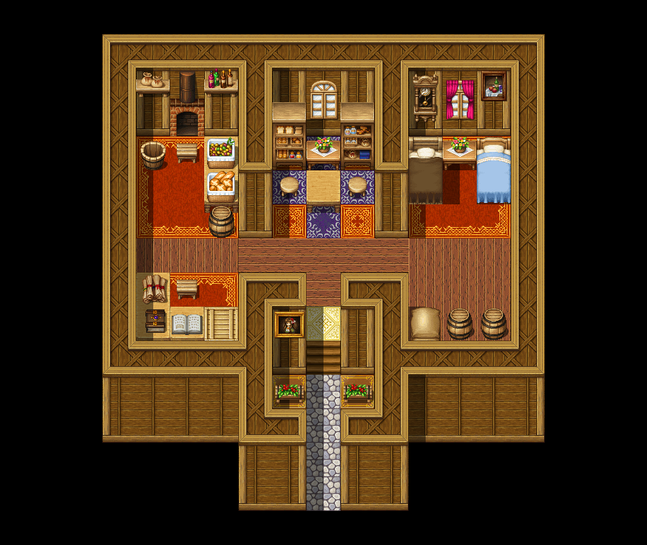
4 Home
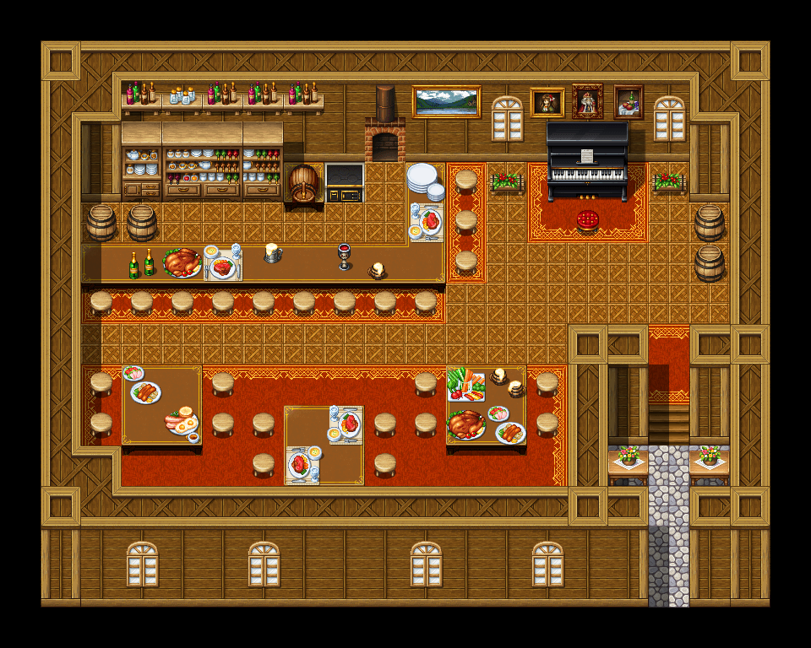
5 Bar
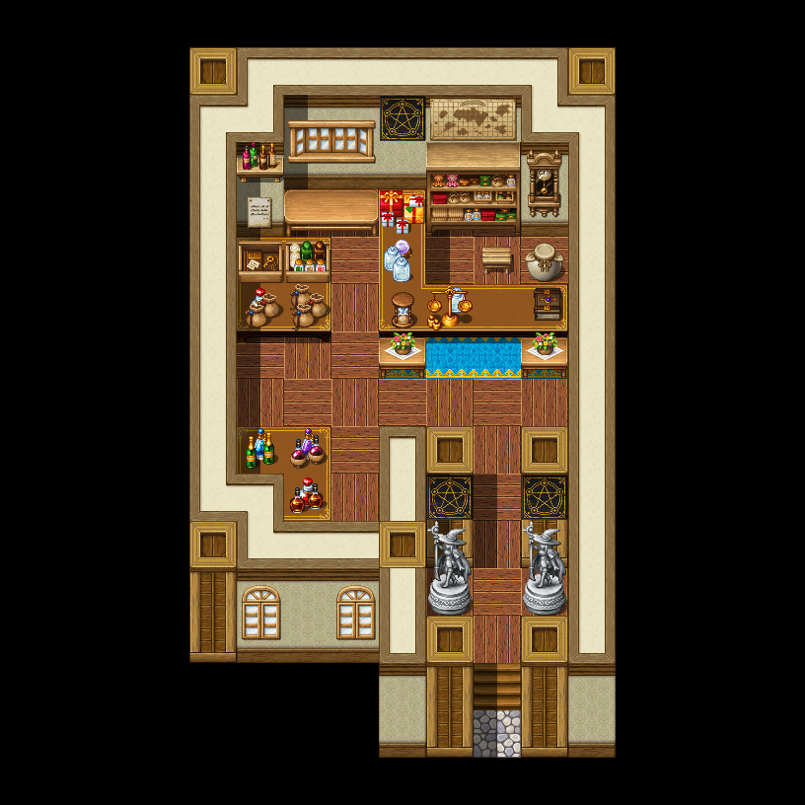
6 Item Shop
The red circling indicates the spot at which inspection can done.
The red lines indicated the border at which the player cannot pass, or simply, define the space which they could move inside while showing which part can’t be passed into, or through

Jungle:
Jungle image can be looped, with options: Turn left, Turn right, Go straight, Leave (teleport to naviagtion area). There won’t be any special effects no matter which choice you individually choose.
With the right sequence, however, one can reach the 2nd version of the image with a cave.
Jungle have 1 subareas or entrance: The Cave (leads to Cult Altar subarea), locked and needs certain knowledge clue.
The red lines indicated the ground player can walk on in the jungle. Otherwise, on the cave, it defines the space at which player can’t pass through .

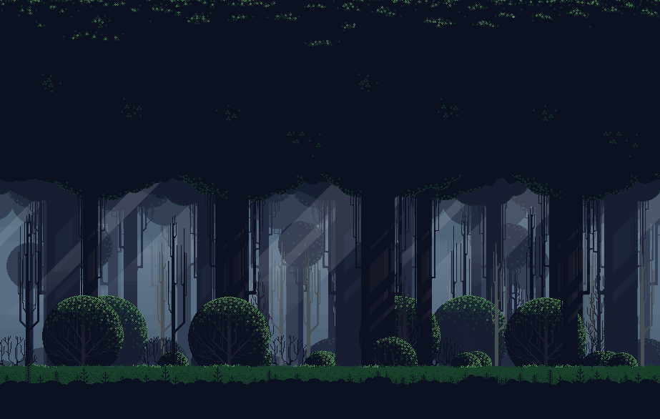
7 Jungle 1

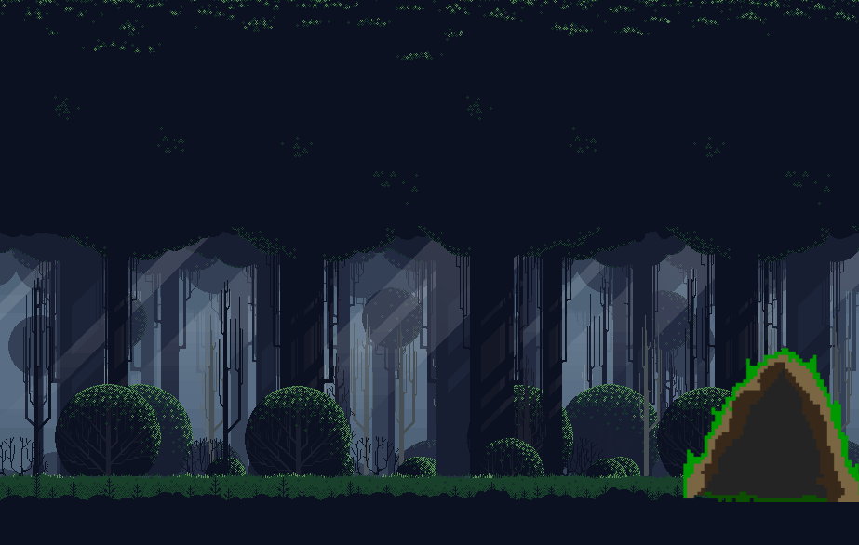
8 Jungle 2
Outer God Altar Area: Contains an item that permanently show Corruption Meter for the entire loop
The red circling indicates the spot at which inspection can be done and where the item is
The red lines indicated the border at which the player cannot pass, or simply, define the space which they could move inside while showing which part can’t be passed into

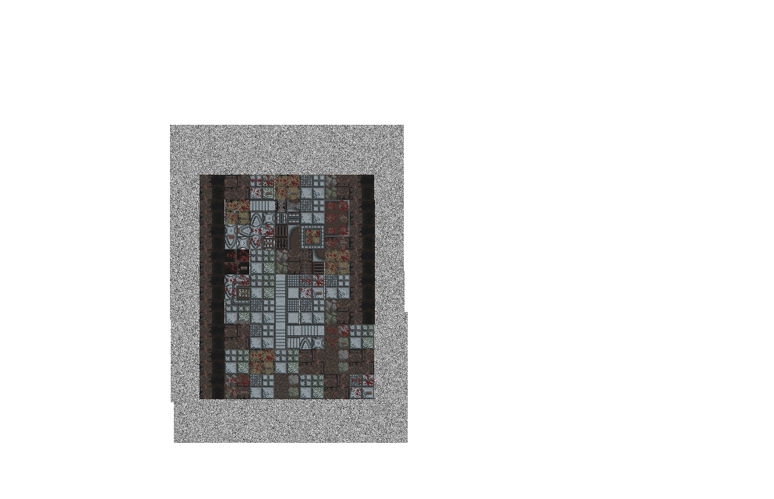

Seer’s Hut: Seer is located there. Subarea locked after 4 service for the loop.
It’s the area to the top left, behind those mountain things. Those mountain things are basically the locked part in NavigationArea that needed unlocking by knowledge clue that
“The cliffs aren’t dangerous” and “Someone lives down there.”
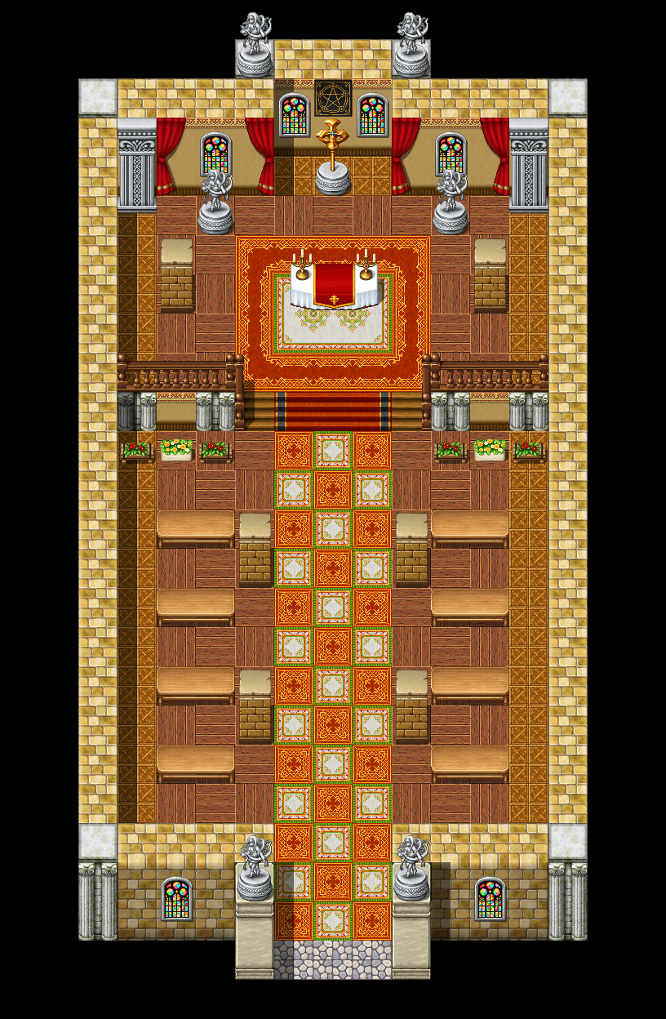
The red circling indicates the spot at which the Seer’s Hut is located.
The red lines indicated the border at which the player cannot pass, or simply, define the space which they could move inside while showing which part can’t be passed into

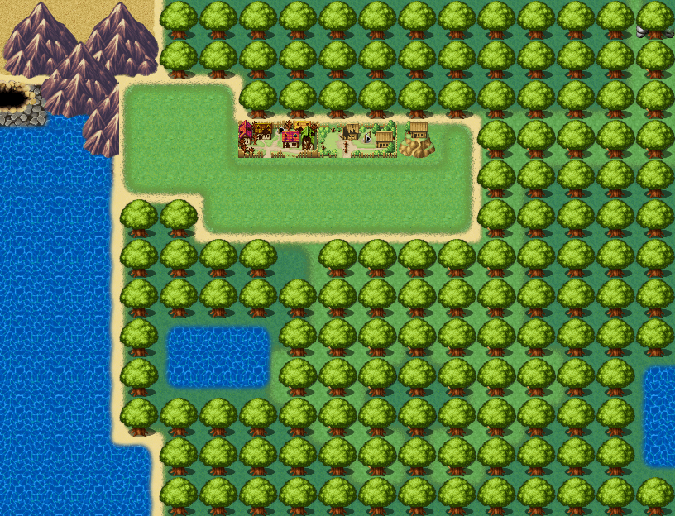
9 NavigationArea 2
Temple: Can be visited and inspected.
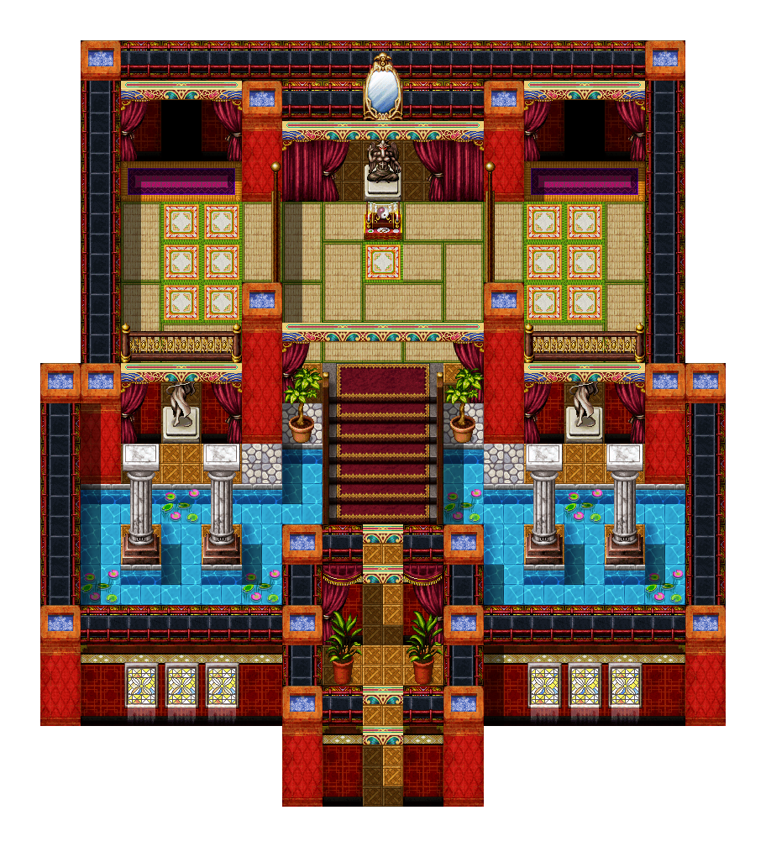
Inspected dialogue will change if player obtained a specific knowledge clue, allowing player to talk to a special NPC-like being called God of Give and Take.
There are 3 options:
+ Ask Questions (branch into “Who are you?”/”What is happening?”)
+ Receive Help
+ Quit (stop the dialogue)
“Receive Help” is a dialogue option where Player can receive 3 help that span all loop (meaning once 3 help is up, it can’t be refreshed by loop.
For example, 1 help was used in loop 2, there will only be 2 help left in loop 2 to 7. If all help expired in loop 5, no remaining help will be available for loop 6 and 7). The help are:
Escape (leads to an instant game ending, not bad end)
Regain Humanity (cleanse 100% corruption meter)
Reveal True Favor Balance (includes hidden favor, last 2 loop).
The red circling indicates the spot at which inspection can done/dialogue with God of Give and Take.
The red lines indicated the border at which the player cannot pass, or simply, define the space which they could move inside while showing which part can’t be passed into or through.

+ Dialogues: A crucial mechnanism in the game.
Appears when Player talks to NPCs,
Interacting with objects by inspecting, by an event,…
Dialogues are preset for most objects, however there are conditional ones that only appear when certain conditions are met (period, day, knowledge clue). As mentioned above, these conditions can trigger at a specific period (for example 3rd day, 1st loop, evening), where an unique dialogue option may appear.
This will require a time system, something to monitor time and let NPCS (including special NPCs)
There are also unique favor dialogue options. “Spill a Secret” and “Kill Thyself” are default locked options for everybody except Daughter and Seer within Favor Request section. The reason why they’re locked will be explained below.
Dialogue’s main component include a main dialogue box that displays character lines
(dialogues). This is elaborated in the above section.
+ Favor:
An intergral part of the plot progression and dialogue system.
Each NPC will have an unique Favor relationship with player (Favor – Favor).
Players can gain favor by doing daily requests (subjugation, watch the house, etc…). Only Subjugation request will have you automatically moveed to another location to kill monster and fulfill the number required.
Other just black out (screen black out) and take the AP accordingly. NPCs may gain favor by Player asking them to look after the daughter (1 default request), which when enough, allows them to refuse an unique favor dialogue option if the number match, or the number from the NPC prevails.
Example:
Ask NPC to spill a secret when Player - NPC (spends 15 – have 16) -> Player lost 15 favors,
NPC favor reduced to 1.
This doesn’t demonstrate that player can only have 15 favor on the npc, but rather that as long as the npc have more favor points than the favor dialogue option cost, they can refuse it with a preset refusal.
There are two separate parameters for favor. It’s assumed that player’s favor with every npc
starts at 0 (0 – 0) meaning no one can use favor against each other. This is the present favor.
However, these is (lore-related reason) a hidden favor parameter that player may only know
off when enough knowledge clues is present. Since favor is unique from NPC to NPC, the
amount is a little different but not substantial, and requires different knowledge clues for
each NPCs.
+ Corruption:
NPCs (except Seer and Daughter), Player and Beast are subjected to Corruption.
Beasts have three states: Normal (0%), Partial (1-99%) and Complete Corruption (100%).
The % don’t matter in actual battle mechanic other than stats, just to distinguish what constitutes which states.
Partial and Complete Corruption have a chance of increasing corruption meter in
player when player is damaged (A chance, not guaranteed). Partial is 10% chance to give
3% corruption, Complete is 40% chance to give 5% corruption.
Most beasts will be normal in loop 1, and as more loop went by (maximum loop 7), more beasts will be spawned partial and complete corruption. The total amount is random, increase by double amount at night. Since Jungle can repeat, only 5-10% of total amount is spawned per jungle map.
Corruption stats buff is said above.
NPC Corruption Meter increase randomly per loop (lower end: 11%, upper end: 17%). At
50% corruption and above, certain effects will happen. 50 – 60% (Dialogue text corrupts, certain letters disappear or just outright a sentence inbetween)
60 - 80%: Alongside the above effect, there’s a chance their house will be their placeholder
instead of their sprite – meaning they locked themselves inside like being sick. They can
trigger (gacha) either the normal talk or refusal to talk).
Special Note: The Recluse will be like this from the beginning (0% Corruption). You can
inspect the house 3 times and the Recluse start talking.
80 - 100%: No respond, only a preset dialogue of suffering can be heard in house
Player:
Gain 10% Corruption when new loop starts.
Gain 10% Corruption when not staying home at night (Spend 1 AP outside of Home at Night
period)
Loser 25% of total Corruption if stay at home at night (Spend 1 AP at Home at Night period)
Corruption Meter retains through loop (retains %).
Gain 10% Corruption per death and instantly jumps to next day per death (beast kill).
At 77%, daughter can give subtle special warning dialogue three time when talk to (warning
happen 1/day). After 3 warning, if retain or > (higher) percentage, instant bad ending
“Preservation”. Details also mentioned above. Warning appear in the form of a dialogue box.
Loop: There are 7 loops total. Player start at loop 1. If by loop 7 daughter wasn’t exposed,
receive ending “Lullaby”.
Endings: Ending instantly end the game, no new loops.
Knowledge Clues: Obtainable per conditional dialogue, quests. Persists through loops.
AP: Action points, can forward periods of a day. 2 for Morning, 1 for Afternoon, 1 for
Evening, 1 for Night. Most action like daily request spends 1 AP, talking (click unchosen
dialogue options) spends 1 AP,….
StoryQuest: Like Conditional Dialogue, only appear at certain periods and for specific NPCs. Spends 1 AP, tracked progress by knowledge clue obtained and npcId talked.
Inventory: Player has an inventory with 5 item slots. This is technically like a bag too, so
there is no separate bag.
Death: If player died (all hp depleted, possible by beast), immediately go to 1st day of next loop after the usual transition of night day 4. If it’s in Loop 7, immediately trigger “Lullaby” ending
Stats: Player have fixed stats: HP (Health), ATK, Defense, Agility, Dexterity (Crit chance, crit
damage is x2 ATK). These stats will decrease by 20% at 50% Corruption, 10% further
decrease per extra 10% Corruption. These will affect movement and combat mechanics
(move slower per lower agility, deal less damage per hit, take more damage per hit,…)
+ Tracker: There are several tracker (functionally and technically speaking) this game should contain: - - - - - - - -
Time System/Some kind of time tracker: Track the period of day (Morning/Afternoon/Evening/Night, intergral to event and unique dialogues), the loop number (intergral to plot progression system), and the day number (eg. Day 2). That’s it for now.

Favor Tracker: This will track all favor relationships and allow the activation of favor
dialogue options, as well as the balance at all times to make sure the system works
right.
Corruption Meter: This meter is hidden by default to player, keeps track of Player’s corruption from the beginning to ending (starts at 0%). An item/something from Cult Altar can reveal this meter permanently for the loop, and Seer can reveal it for a day.
HP meter: A bar of health that regenerates after a day ends (after night passes).
Doesn’t regenerate during the day.
Subjugation (some kind of tracker): Subjugation daily request can track how many beasts were killed. The total amount kill per type can be tracked as well, and when 100 is killed, mobs (Normal) of the type can be insta-killed.
Quest (some kind of tracker or using json data parsing or the likes): Track which quest have been finished and disable it for the player.
Makes sure that if player have earned a knowledge clue after finishing such quest
(maybe in previous loop), that knowledge clue remains.
KnowledgeManager or some kind of tracker: Track All Knowledge Clue and which the player have obtained, divide into two categories named “Obtained” and “Unobtained”. Integral to access of certain special conditional things like Cult Altar, God of Give and Take,…
Dialogue (some kind of tracker?): Track which option has been triggered and which is not. Track conditions that allow which options to be available or not through other tracker like Time tracker (placeholder name for system that tracks time and move it).
Suggestion: Options can be just normal dialogues or Chat (Must), Daily Request (Must), Story Quest (Conditional), Favor (Conditional)
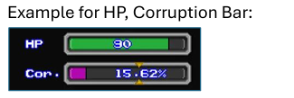
Although called an example, might be better currently to have only text.

Data: Most data is orchestrated and written in json, which is later parsed into the class that will use that data.
These data includes:
+ Player information
+ NPC information
+ Dialogue trees
+ Dialogue nodes
+ DailyRequest: Subjugation Request/Inform Request (Inform
+ StoryQuest
+ Knowledge
+ Map (maybe includes blocking and mapping definition like [0,1,…] ?)
+…(etc.)
Among these data, maybe for the likes of NPC, it would also have their sprite link? This will depend on how we decide the implementation.
The current idea may expand even more in the future. This is basically a prototype idea.

Game Overview Summary:

🎮 Title
Not specified yet, but the game is a time loop, mystery-adventure RPG with combat, dialogue, and exploration mechanics.

📜 Core Lore & Narrative
You play as a knight father who once deeply cared for his young daughter.
The main setting is a village that upholds a long running belief system of Favor, blessed by The God of Give and Take. Favors are absolute, earned as values through completing each other's request which can be used to ask the requester later down the line to "Return the favor", or do a task that befits the amount of favor value used. Favor doesn't completely override free will until a certain amount is achieved, where even absurd request are possible and the one who had to fulfill that favor can't refuse (like 50 favor for killing yourself, this is just an example). Fulfilling the favor would clear that favor values (so it's technically favor value for one, favor debt for another)
The father's parents, both well known knights, sacrificed against a great beast (not elite beast, it's basically like a boss, but not in this game) to protect the village, even though the shrine inevitable collapsed when that beast spread its destruction. Despite efforts of restoration, the shrine ultimately couldn't be restored (the reason is due to an outer god's influence). The shrine was once a place to measure favor balance correctly thanks to God of Give and Take's scale, allowing for villagers to fairly use favor requests without the need to keep a note on how much they have on which person. However, with the shrine gone and the god nowhere to be heard, they began to uphold this system in a more primitive way. This inevitably led to them discovering a "loophole" where they can fulfill favor to a bare minimum and declare it done as no divine punishment befell them.
Of course, that wasn't so for the god, who continues to stack favor debt without them knowing.
The father, raised from child was carefully done due to the great favor they owed to the parents (their lives being protected) and that the Knight Order paid special attention to the father as they were son of the heroes. That's why even though he hated the coldly logical favor system, he trusted it to do its job, because he felt the care in exchange for the favor was decent. He, idolizing the valiant heroes that was his parents, trained and soon become a knight. An unofficial Knight. To be recognized, he had to serve service and prove himself, which led to his inevitable trip. He had a wife and daughter in the process, a wife who died shortly after the daughter was alive, and a daughter who's young enough to not be able to take care of herself even if she's aware of everything around her (even her dad care and love, as well as her mom's)

Fearing for her future due to his inevitable departure to knight service which stops him from being able to care for her personally, he starts fulfilling requests more and more to stack favors with the villagers, and in the process neglect his time with his daughter.
After he left her in the care of the villagers, they began the hypocrisy of treating the daughter with bare minimum care to repay his favor, utilizing the loophole in the process. Treated poorly and unloved, the daughter soon grew resentment towards the villagers as years go by, wishing her dad to be back. However, before long, a being called Outer God reached out to her, tempt her with power to punish these wicked people that took advantage of her father's time and treated her badly even with how much favor her father accumulated just for her. (Technically due to how vague her father's request was, thinking the villagers wouldn't do such things to a child)
She started the looping which by time, slowly rot the villagers and beings within her affect range's soul. This was by the time the father (our protagonist) returned to town (1-2 loop has gone by). She wanted to see what his choice was, because she knew that it was him who chose to neglect his time with her for her, which in the end brought nothing but misfortune. She loves and care for him, but also wanted to punish him for trusting this system and neglect his time with her for it.
The father arrived relatively intact, seeing the village has not changed much in the slightest. Little did he knew, something was already on its way.
She gave him 7 loops, an information he doesn't know, it mirrored the stormy week that he stayed by her side to care for her, and only for her. Her most memorable time of love and care with her father.

Only he retains awareness as loops went, but the loop itself is initiated by the daughter with the Outer God's power.
The Outer God considers her a pawn, but doesn't interfere with her too much.

The goal is to uncover why the loop happens, rebuild bonds, discover hidden truths, and find a way to break the loop — or find peace within it.
If the corruption meter, a game mechanic, passed a threshold, then it's an automatically bad ending as the daughter encased her father within eternal void and darkness so he won't end up like other villagers who passed that threshold. (ends all loops as well, since the daughter have no reason to prolong it).
If the father experienced near-death (in game is death or out of hp) in a subjugation quest, the daughter will "revive" him and automatically push toward one day. If it's the last day of the loop, automatically start next loop.
The daughter will always be home if the father entered the house to home, but if he left, whether she is there or not depends on the game.
I have not configured more endings, but I would like one of them to be named "Your Original Sin" and have something to do with a cheap cream bun that can't teach love (the latter can be part of the story instead of ending trigger).

⏳ Time Loop Mechanics
Each loop spans 4 full in-game days.
On the 4th night, your daughter tucks you in, and the loop resets.
Some actions persist across loops (LoopMemory), such as:
Information
Flags/unlocked conditions

Other things reset, like:
Items not intended to carry over
NPC positions, schedules, etc.
NPCs and player both accumulate Corruption from certain actions over loops.

